DATA PREPARATION FOR DATA ANALYSIS
INTRODUCTION
The key starting point for data analysis is data acquisition and preparation because raw data is rarely in a usable form. You can connect to import data into Power BI from a range of connections and sources, including databases, spreadsheets, or through online services. After you have imported the data, you will want to preview the data because previewing the data provides an opportunity to understand what data you have, determine if there are missing values, get a sense of quality and provide an opportunity to determine what corrections if any are required before you continue with your analysis. After this step, the process progresses to data processing and data cleaning, where all errors, duplicates, and inconsistencies are addressed and the data would be reliable. The data transformations would be used next to shape the dataset into a more meaningful dataset which aligns to your own specifications for analysis. You can then create and run queries that will import each dataset as tables into your semantic model which can provide you with a reliable model of your reports and helpful visualizations.
AIM
To prepare data for data analysis and create relationships, new measures and new table using Power BI.
OBJECTIVE
The main objectives are:
- Power BI will bridge data from various sources like CSV files, databases, and cloud services.
- In Power Query, preview and profile to see missing values, errors, and other data quality problems.
- Proceed with proper data cleaning practices. Remove duplicates, handle null or blank rows, deal with column headers, etc.
- Proceed with the data transformation processes.​ Alter datatype, split and merge columns and so on, aggregate, so that your dataset is compiled.
- Next, structure the data into a data model (fact and dimension tables) for razoring up to analyze.
- Load your prepared data into the Power BI semantic model for reporting, dashboard, and visualization and prepare it for building reports, dashboards, and visualizations.
WHAT IS DATA ANALYSIS
Data analysis is the process of discovering important and precious data by investigating, cleaning, transforming and modeling data. The data is then presented as a story using reports to conduct analysis to help support the decision-making process that is increasingly becoming a critical consideration for organizations. In order for data-driven organizations to help decision-making, they consider the story the data tells them (success or failure). In the data-driven world we live in, data is not being utilized to its fullest extent, which is one of the problems encountered by the majority of organizations. Data analysis is and should always become critical for a successful outcome for organization to determine the impact to their organization which can include customer sentiment and satisfaction, product and market research and identifying trends or other data relevant insights.
The data analysis process is more about the actions i.e.
- Cleaning
- Modeling
- Visualizing data
the data analysis and its importance to business should not be understated.

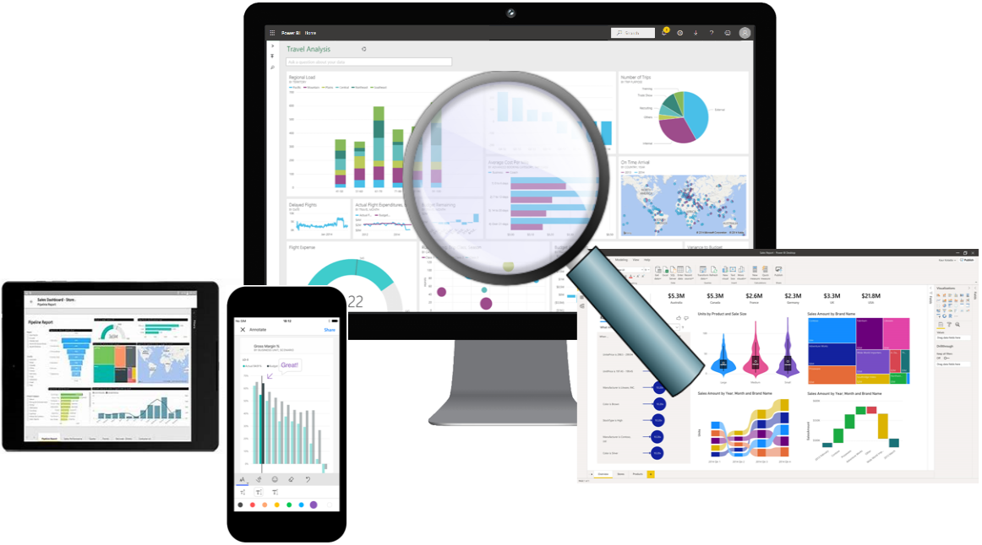
Source: Microsoft Learn

WHAT IS DATA PREPARATION

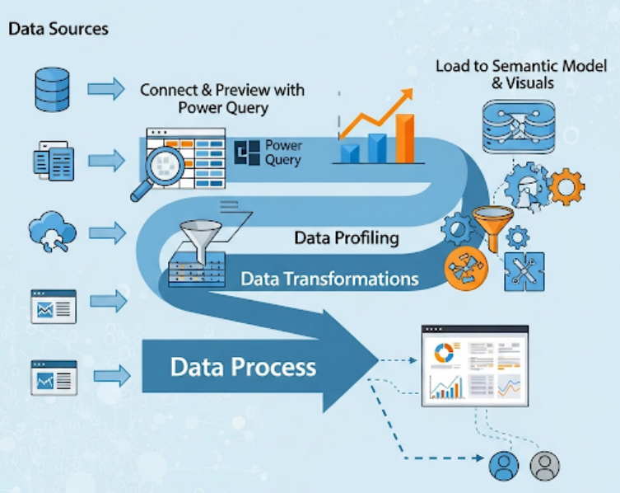
Figure 1: Data preparation process
Source: Created by Gemini AI

As per figure 1, The data preparation and data processing cycle in Power BI is illustrated. The organization starts by connecting to some data sources such as databases, spreadsheets, cloud services, or third party applications. After establishing a connection with the data, it is imported into Power Query, where users will see the data and begin profiling the data. Profiling the data allows the user to view the underlying structure to find errors, null or blank or empty values, and assess quality. Next, the users will transform the data. Data transformation includes cleaning, re-shaping raw data. Data transformation can consist of removing duplicates, filtering out rows from tables, splitting or combining columns, changing data types, and aggregating values. Once transformation is finished the data is now reliable and consistent. Following the cleaning of the data, it proceeds to processing. In this phase the data will be modeled and organized in such a way that communicates something meaningful and demonstrates relationships between the data. Users will be creating fact tables and dimension tables to help provide more sophisticated analytical opportunities. The analyzed and processed data is loaded into a semantic model in Power BI to produce the interactive visuals, reports, and dashboards.

LEARNING OUTCOMES
It includes how to
- Connect to different data sources.
- Preview source data with Power Query.
- Use data profiling features in Power Query.
- Apply various data transformations.
- Load queries to the semantic model.

PRE-REQUISITE SETUP
- Before starting, ensure the following setup is ready:

- Software Requirements
Power BI Desktop installed (latest version recommended).
  - Internet connection for downloading datasets and connecting to online sources.
- Dataset Requirements
  - Download the Retail Sales dataset from Kaggle:
Retail Sales Dataset - Kaggle
  - Save the dataset in a local folder that can be accessed by Power BI.
- User Knowledge Requirements
  - Basic understanding of Power BI Desktop interface.
  - Familiarity with importing data and using Power Query Editor.
  - Basic knowledge of data types like numeric, text and date.

IMPLEMENTATION STEPS
- Get data from CSV file
- On the Home ribbon tab, from inside the Data group, select Get Data and select Text/CSV from the dropdown list.

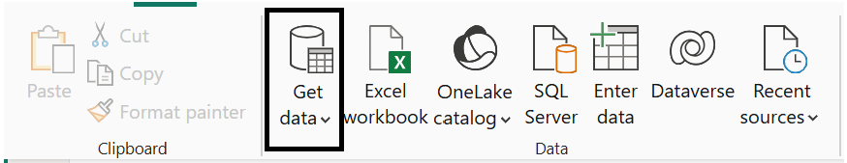

- Select the Retail Sales Dataset and import it. Notice that it has columns names. Now, select Transform Data to proceed with the data cleaning and processing.
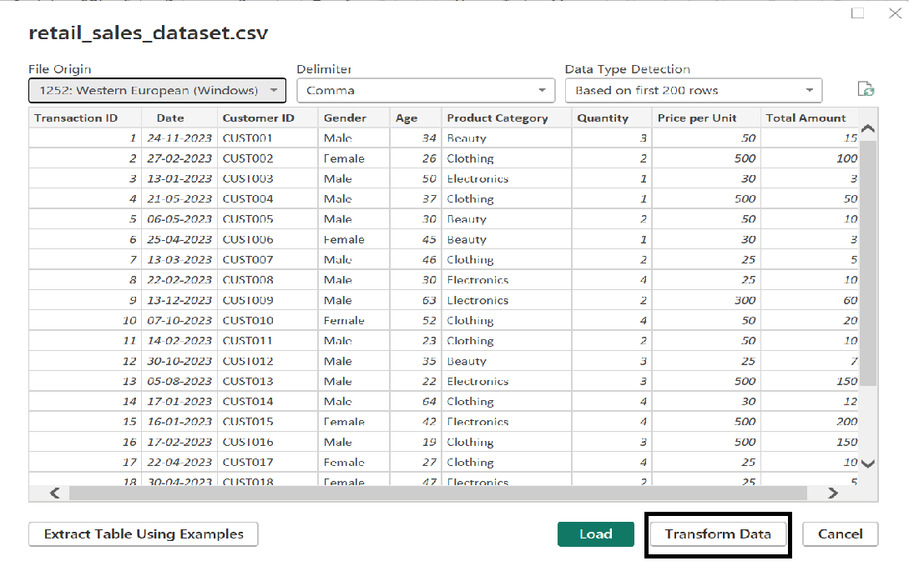

- Transform data will open Power Query Editor. This completes the process of getting the data from sources (csv file). In the Power Query Editor, data can be previewed and column quality, profile and distribution can be viewed which will help in data cleaning process.

- Column quality and Column distribution
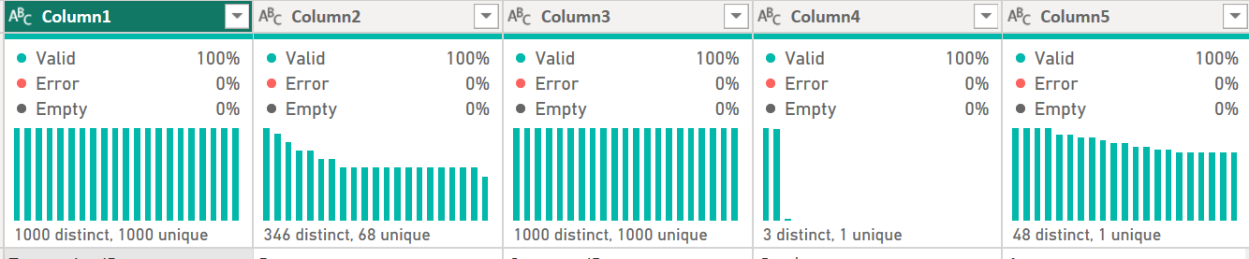

This is called the Data Profiling View which gives the gives you an overview of the data in each column. The Column Profile gives detailed statistics about a column and Column Distribution shows a visual frequency chart of values in that column.

- Clean, transform, and load data in Power BI
- Click transform data which will open Power Query Editor.
- In the Power Query Window, notice that the column headers are named as column1, 2, 3. To do so, On the Home ribbon tab, from inside the Transform group, select Use first row as headers.
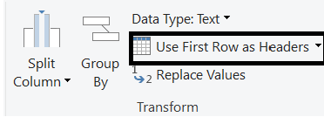
Now the first row is displayed as column header.

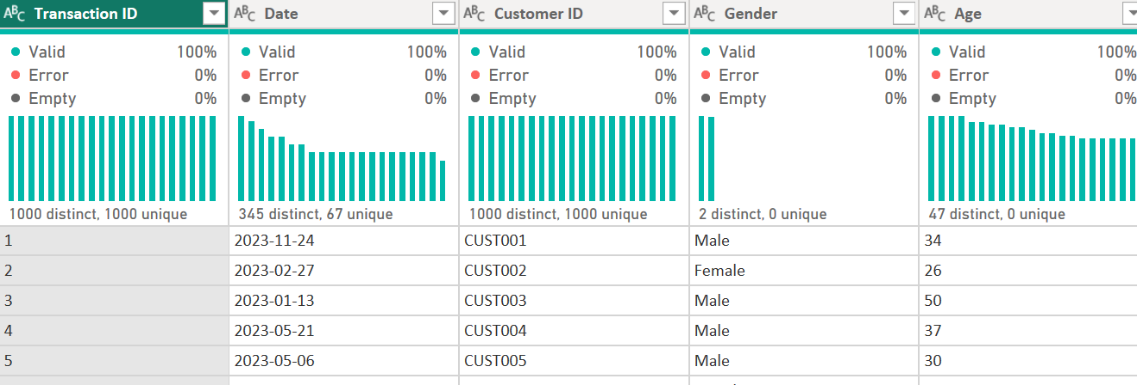

- Column datatypes should be checked and changed to appropriate datatypes as wrong datatypes can cause inconsistency.
- Date Date
- Quantity, TransactionId, Age Whole Number
- PricePerUnit Decimal

- Remove null/blank rows so that aggregation function will work properly on the dataset.

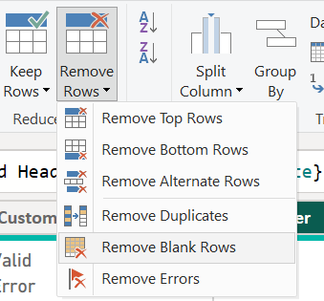

- In the Query Settings pane, under Applied Steps list, notice the addition of the Filtered Rows step.
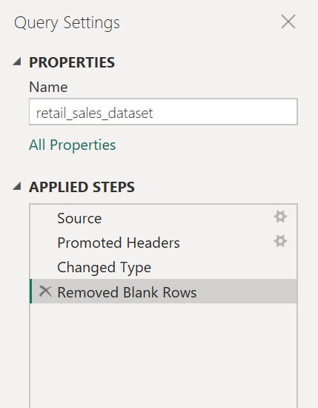

- Select Close and Apply in the Home Ribbon. This will result in completion of data transformation process.
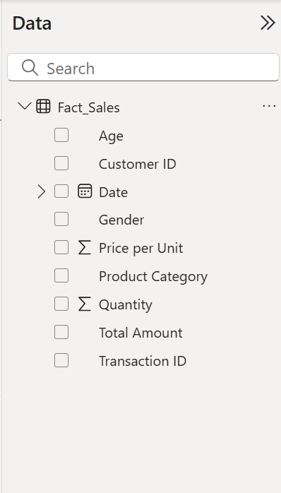
- Creating Fact Tables and Dimension Tables
- Rename the query as Fact_Sales as this query will act as fact table.
- Note: Fact Table is the central table in a data model that contains measurable, quantitative data used for analysis. It stores the numbers or metrics we want to analyze, such as sales amount, quantity, profit, or revenue, along with keys that link to related dimension tables.

- In the Modeling ribbon, under Calculations, select New Table and enter the DAX Query.
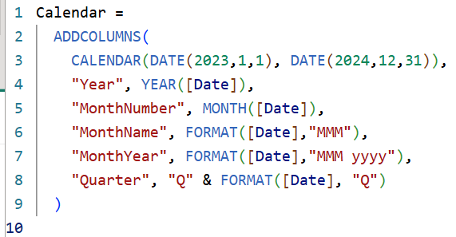

- In the Fields pane select Calendar Table, In Modeling ribbon, select Mark as date table and choose Date column.
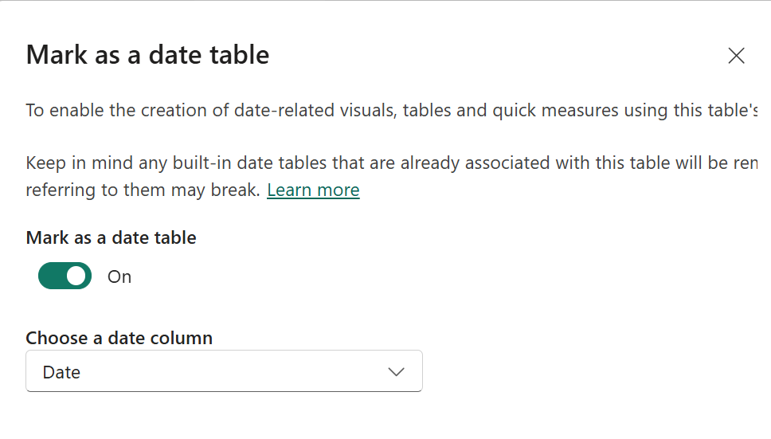

- To create Customer Table from Fact_Sales Table, Go to Power Query (Transform Data) and right-click Fact_Sales table the select Reference.
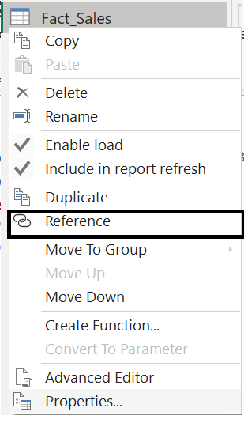

- In the new table, keep only the mentioned columns and remove other columns.
- Customer ID
- Gender
- Age

- Remove duplicates and rename the table to Customer then select Close & Apply.
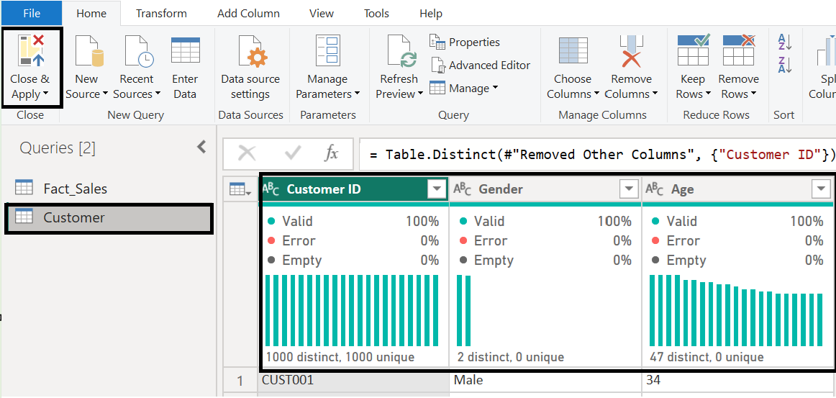

- Create Relationships in Model View
- Click Model (left-side icon) and drag Fact_Sales[Date] to Calendar[Date]. And also drag Fact_Sales[CustomerID] to Customer[CustomerID].
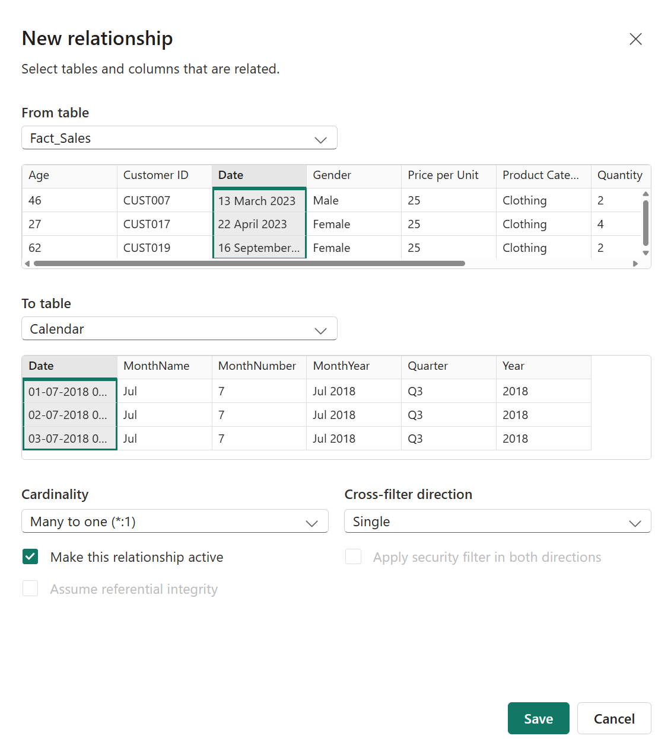
 Important: Ensure cardinality usually Many to One (*:1) with Sales on the many side. Cross-filter direction is single initially.
- Finally, In Model View the relationship will be as follows.
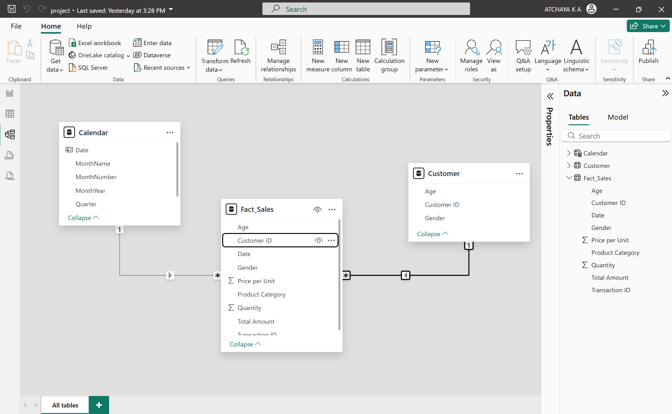

- Create DAX measures
- In Modeling ribbon, under Calculations, select New Measure and enter the DAX queries and create following measures.
- Total Sales = SUM(Fact_Sales[TotalAmount])
- Total Quantity = SUM(Fact_Sales[Quantity])

- Important: Make sure that the table name, column names in queries are same as Table and column name in the data as Power BI is Case-sensitive.

- Then, In Model View select all the measures and in Properties Pane enter the display folder as Measures and organize it.
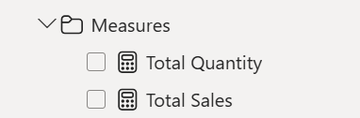

RESULT
In the Data pane, Fact_Sales table is visible which shows that the dataset has been imported into data model after transformation.
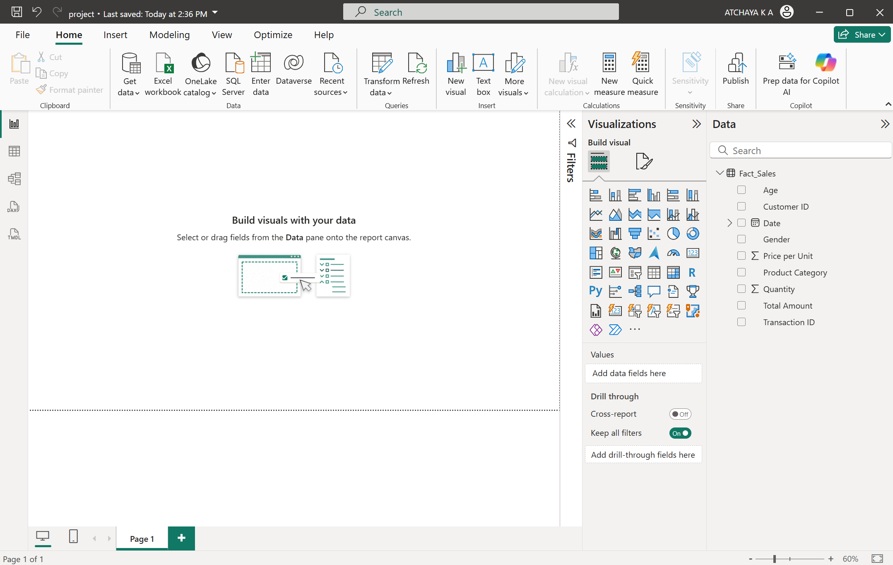
In Model view, Fact Tables and Dimension Tables, their relationship can be seen. Also new measures, new table that we created is seen in the Data pane.
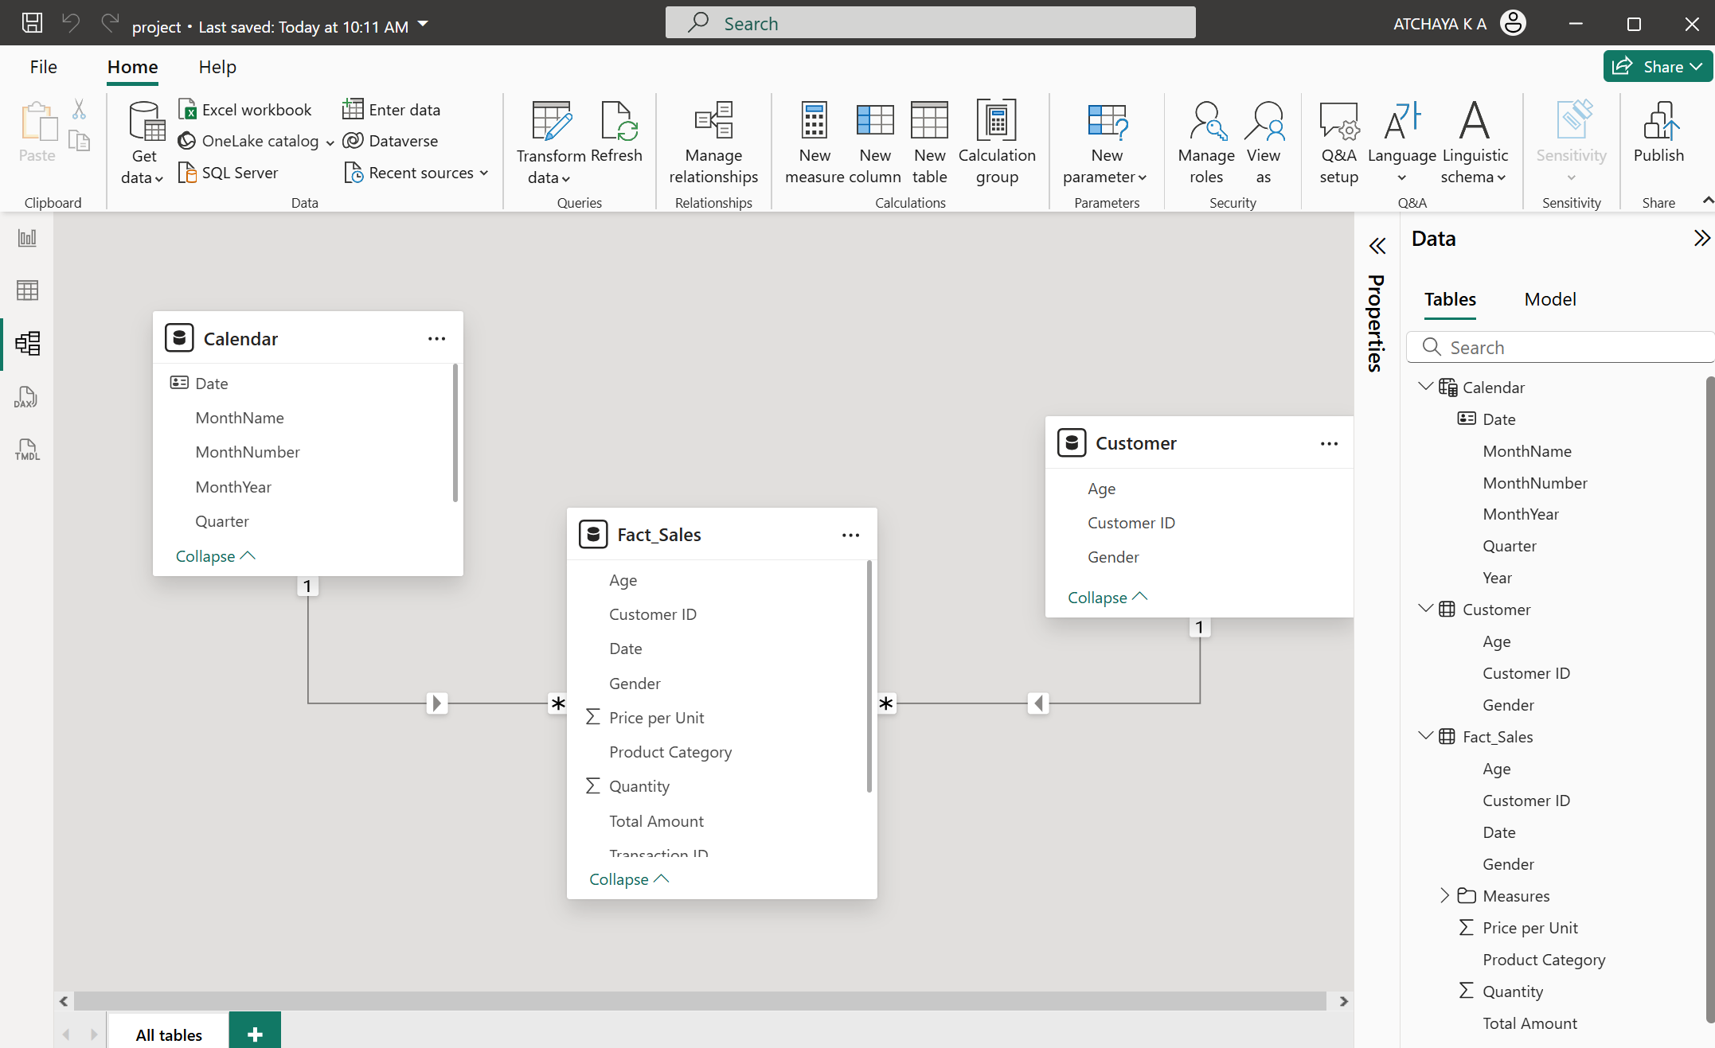
CHALLENGES
- When preparing the data in Power BI, we can experience issues with missing or duplicate values, changing wrong data types, and working with null or blank rows.
- Modeling Relationships that is building accurate fact and dimension tables, and defining correct relationships can be (cardinality, cross-filter direction) can be confusing.
- Working with DAX queries to create measures, tables can be complicated.
- Understanding and applying concepts like semantic modeling, DAX measures, and star schema design.
RECOMMENDATIONS
- Optimize large datasets by filtering unnecessary rows/columns and using aggregations to enhance performance.
- Ensure cardinality usually Many to One (*:1) with Sales on the many side. Cross-filter direction is single initially.
- Strengthen skills in Power Query and DAX through practice and training to handle complex transformations and calculations efficiently.
- Use a well-structured data model with clear fact and dimension tables to simplify relationships and improve report accuracy.
SUMMARY
The document provides an easy step by step process showing how to transform data in Power BI from connecting to a CSV file, to going through Power Query which is the primary working area used to shape the data after being brought into Power BI. It includes looking through the dataset, reviewing the quality of the dataset, and providing changes to enhance quality, in just a few useful steps like renaming queries to clarify purpose, filter out unnecessary rows, provide or merge columns, modify data types, and name the fields meaningfully. Although small these changes can help to make messy raw data easier to work with. This is an important first step, as the cleaning and transformation is completed the data is turn-loaded into the semantic model, which is the platform for analysis. Creating relationships, measures and tables will also help us in further report building process. To bring some practicality to the document, a Retail Sales dataset is used, which attempted to demonstrate the data collection, data cleaning and transformation steps and also demonstrated the creation of relationships, new measures and new tables which will pave a way for effective building of reports and visuals.
AI TOOLS USED
- Gemini AI: Generate images
- ChatGPT: Generate and verify the DAX queries
REFERENCES
- For further learning, refer
- Prepare data for analysis with Power BI
- DAX Queries, Measures and Tables
- Create and Manage Relationships

- Skillable Labs: Microsoft Skillable Labs

- Microsoft resources: Quickstart: Connect to data in Power BI Desktop - Power BI | Microsoft Learn Shape and Combine Data in Power BI Desktop Tutorial - Power BI | Microsoft Learn
Using enhanced semantic model metadata in Power BI Desktop - Power BI | Microsoft Learn

- Microsoft Learn Video Tutorials: Power BI Tutorials

